Go to the user directory where ever you are cd ~/

Create many folders in one go using the braces ‘{}’ mkdir {jan,feb}_{20..23} we use the ‘..’ in the bracews to identify number or alphbatic pattern {A..Z} or {a..f} for example touch file {jan,feb}_{20..23}/file{a..u}.txt Note with [] you do not need ‘,’ comma while you need it with {} but no space is allowed

Great example: mkdir -p term{1,2}/week{1..9}

wc     word count command

find / -iname “*.txt” -size +100k -o -size +5M | wc -l find all the files and folders that end up TXT and the size is more than 100 kilobytes or less then 5 mega ….. we can add -f to find only files or we add -d to find only documents or folders

find / -macdepth 3 -size +100k -size -5M -exec cp {} ~/Documents/test \; find all the folders and files and search in the maximum depth of three which means do not go in subfolders more than three layers and find the file that has a size more than 100 kilobytes and less than 5 megabytes and execute the following CP stand for copy and the curly braces stand for the file or the variable that you find and copy that to the document test directory and the\ semi Collins means end execution command

We can replace the -exec command with -ok which will ask before each execution It is safer when delete something class 39 Linux Udemy Ziyad

Cat command and its use with mp3 class 41 Linux Udemy Ziyad

Important if you write shebang which is the hash and the bang in the top of a file then bash the computer will treat the file as a bash file while if you type user bin python the computer will treat it as a Python file you can find the directory of the Python when you type the command “which pyhton“

#!/bin/bash

Or

#!/usr/bin/python3

We can run the file using “bash”

Every user has cornTAB for sechdualing tasks

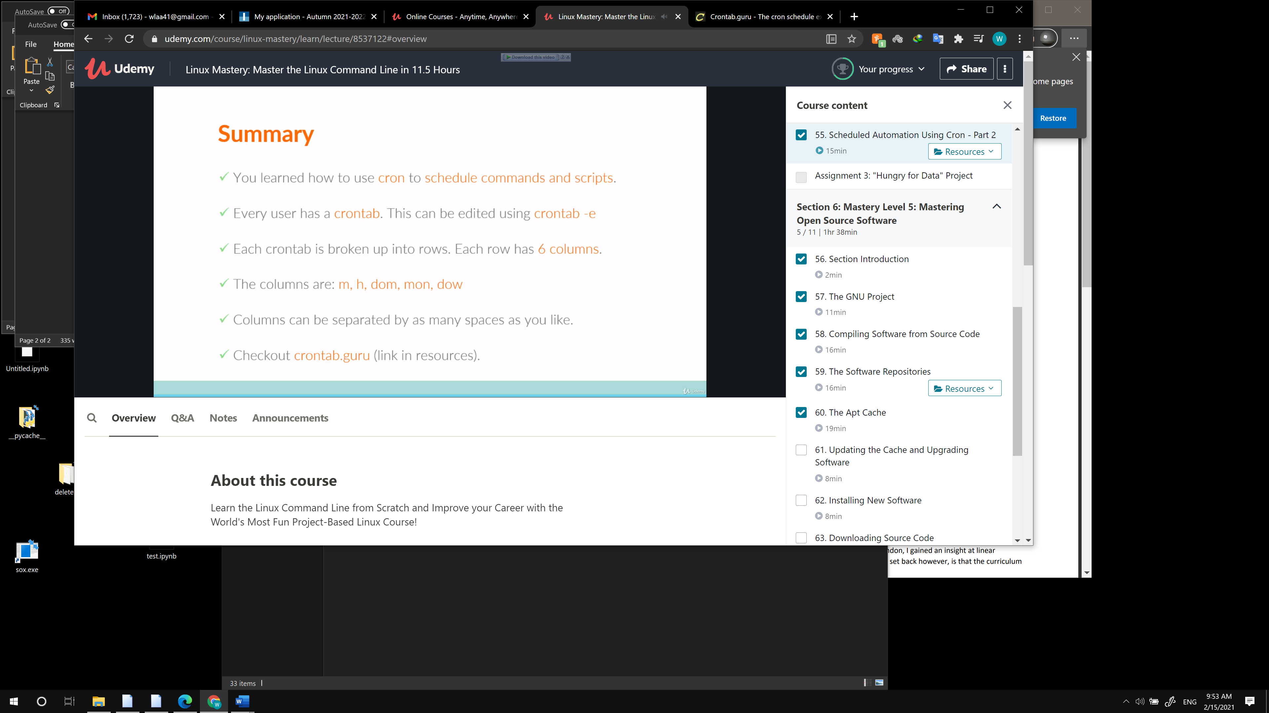

Great Website [https://crontab.guru/](https://crontab.guru/%20)

